**Part B: Documentation (50%)**

Documentation supporting your software development journey must be created using Microsoft Word and include the following sections:

|  |  |
| --- | --- |
| Section | Description |
| Planning | Task Definition |
| Structure charts |
| Flow chart |
| Data Dictionary |
| Implementation | Link to your GitHub repository containing source code |
| Testing | Test table |
| Evaluation | Project reflection |

**Software Engineering Year 11: Programming Documentation**

**Project Documentation: ‘Connections.py’**

Table of Contents

Task Definition 3

Data Dictionary 6

## Task Definition

I have been assigned the task of developing ‘connections.py’, a word puzzle driven python application for the 2023 game of connections, ensuring a functional and fun game play that reflects the game's challenging nature. I aim to execute a will programmed, bug-free application that is user-friendly and more importantly engaging to the user.

The functional requirements I will need to implement include:

* Randomly select 4 categories and in each of those categories it will select there 4 words.
* Display those 12 words in a 4x4 words grid.
* There will be 4 lives.
* For every wrong guess the live will deplete by 1 and for every right answer it will display how many live you have left and congratulate you for guessing all the words correctly with their categories.
* If all your live are less, then 1 so 0 it will display game over.
* Have a restart game function.

**Structure Chart**

This is the approach that I used throughout the development of ‘Connections.py’, this structure chart decomposes the game logic into a mainline and the individual functions within and help visualise the data/parameters that will be passed around.

*This diagram was generated using* draw.io.

**Connections** will be the top-level mainline that starts the game.

**Word categories** is an array of all the categories and words related to the category they are in.

**Create empty grid** will make an empty 4 x 4 grid for the words to be put in.

**Select at random the categories** will be a function that selects 4 categories with 4 words in each for the game.

**Populated grid with four categories** will put the 16 words in the empty 4 x 4 grid.

**Play Game** is the main game loop where the gameplay occurs, including getting the display grid function, get guesses, check if valid and updating the game state. It continues until the player runs out of attempts or puts all the words with their chosen category.

**Update game stats** this will then display the amount of guessed categories (out of 4), and if the lives greater then 0, you won the games if not then Game over.

**Display grid from populated grid** will display the populated grid function.

**Get Guess**: This function simply gets 4 words guessed by the player.

**Check if it is valid** this will check if the guess is valid.

**Play Again Prompt**: After the game concludes, this prompts the player to start a new game or exit.

**Flow Chart**

This Flowchart effectively illustrates the way my game “connections.py” uses detailed operations of subfunctions in a simplified way, this overview should perfectly demonstrate the workings of the game, “Connections.py”.

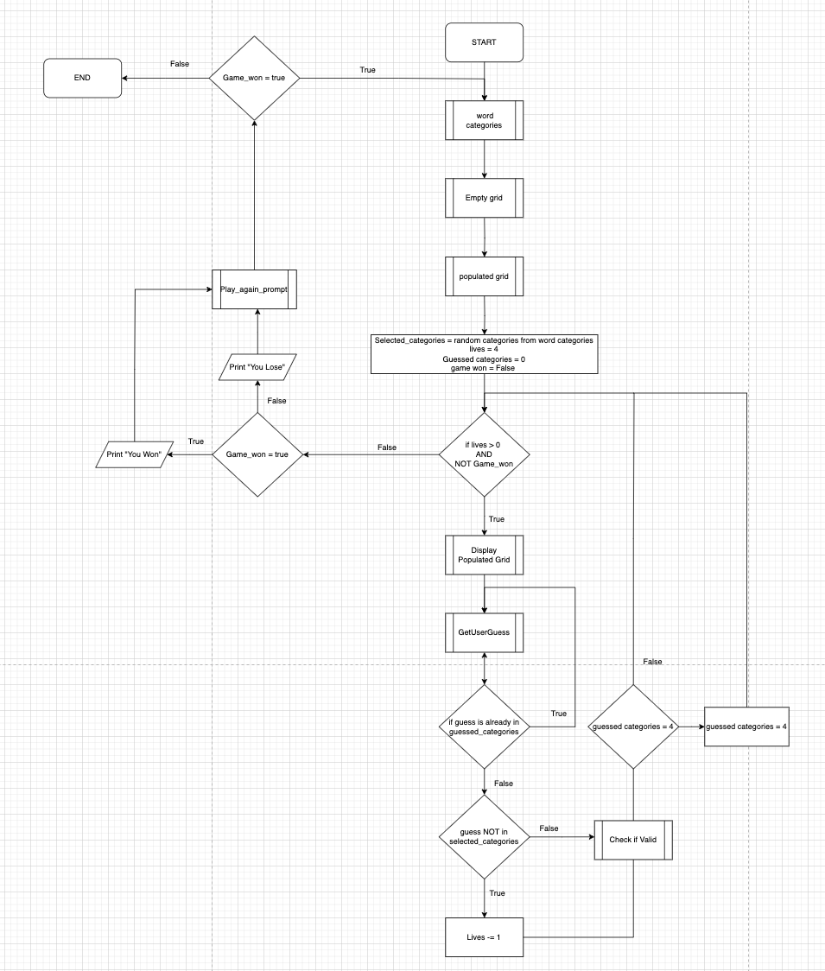*This diagram was generated using* [*.draw.io*](https://www.drawio.com/)

## Data Dictionary

|  |  |  |  |  |  |  |  |
| --- | --- | --- | --- | --- | --- | --- | --- |
| Variable | Data Type | Format for display | Size in bytes | Size for display | Description | Example | Validation |
| Word Categories | List[String] | List of strings | - | - | List of potential Categories for the game | "linking_word":"body_parts", "words": ["Legs", "Arms", "Fingers", "Feet"] | Must not be empty |
| Selected Categories | String | Text | - | - | The word to be guessed by the player | “word”, “word” , ”word”, “word” | Must be from Word categories |
| Play again prompt | char | characters | - | Y/N | Asking if you want to play again | “Y” of “y” for yes  “N” or “n” for No | Yes or NO only |
| Lives | Integer | Numeric | - | 1-2 digits | Number of lives left for incorrect guesses | Live = 4 | 0 to max number of Lives |
| Check if valid | Boolean | True/False | - | True/False | Flag to determine if the game has been won | True/False | True or False only |
| Getuserguess | string | multiple characters | - |  | Current letter guessed by the player | “input” | Multiple characters |

## Link to your GitHub repository containing source code

## Test Table

|  |  |  |  |  |  |  |
| --- | --- | --- | --- | --- | --- | --- |
| Test ID | Category | Test Case Description | Input to Provide | Expected Output | Actual Output | Pass/Fail |
| Test 1 | Path Coverage | Verify attempts increment on multiple failures | An incorrect combination of words 4 times | Lives counter reaches 0 and game ends | “You Lost”  “Play Again (Y/N): ” | Pass |
| Test 2 | Boundary Value | Check behaviour on last attempt | Correct guess after 3 incorrect guesses and an additional 3 more correct guesses | You have won.  Play again | “You have won”  “Play Again (Y/N): ” | Pass |
| Test 3 | Path Coverage | Validate win condition with minimum guesses | get 4 correct guesses | You have run out of live game over | “You have run out of lives game over”  “Play Again (Y/N): ” | Pass |
| Test 4 | Faulty Data | Input non-alphabetic characters as guess | '1', '@', '-' | incorrect | Incorrect | Pass |
| Test 5 | Abnormal Data | Enter an already guessed word | Correct word guessed twice | Incorrect! | incorrect | Pass |
| Test 6 | Path Coverage / Replay ability | Check game restart functionality | 'y' after game concludes | Game restarts with initial conditions | Game restarted with initial conditions as expected | Pass |

**Project Reflection**